Develop a program that will take marks as input and award the appropriate grade based on USIU's grading system. Use all the necessary control statements.

The program should continue taking marks input from the user and display the appropriate grades and terminate Only upon the user's command. (Hint: use loops).

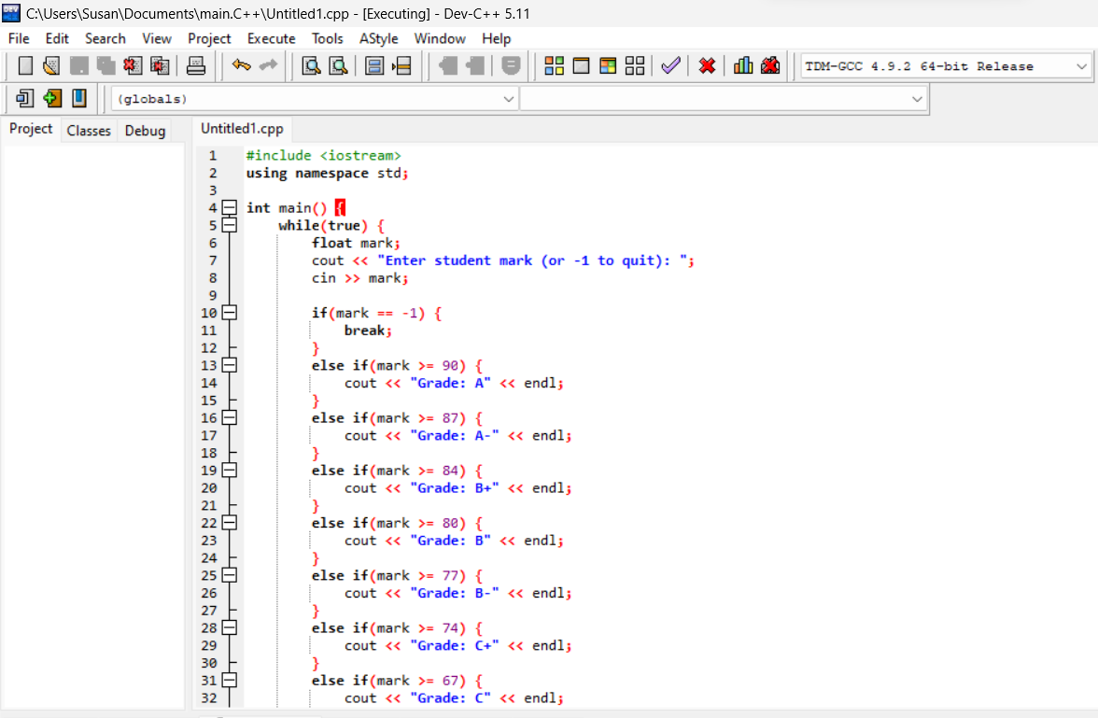

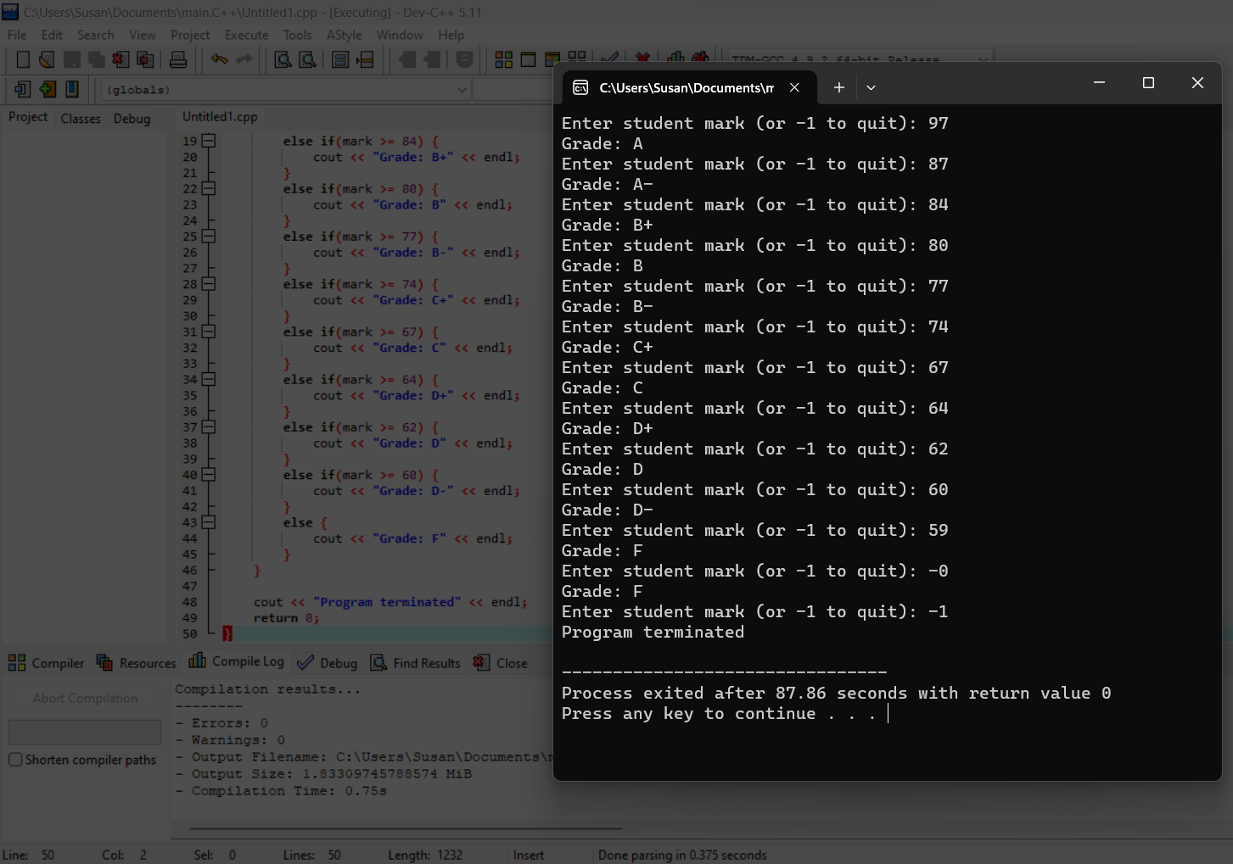

#include <iostream>  
using namespace std;

int main() {  
    while(true) {  
        float mark;  
        cout << "Enter student mark (or -1 to quit): ";   
        cin >> mark;  
          
        if(mark == -1) {  
            break;  
        }  
        else if(mark >= 90) {  
            cout << "Grade: A" << endl;   
        }  
        else if(mark >= 87) {  
            cout << "Grade: A-" << endl;  
        }  
        else if(mark >= 84) {  
            cout << "Grade: B+" << endl;  
        }   
        else if(mark >= 80) {  
            cout << "Grade: B" << endl;  
        }  
        else if(mark >= 77) {  
            cout << "Grade: B-" << endl;   
        }  
        else if(mark >= 74) {  
            cout << "Grade: C+" << endl;  
        }  
        else if(mark >= 67) {  
            cout << "Grade: C" << endl;  
        }  
        else if(mark >= 64) {  
            cout << "Grade: D+" << endl;    
        }  
        else if(mark >= 62) {  
            cout << "Grade: D" << endl;  
        }  
        else if(mark >= 60) {  
            cout << "Grade: D-" << endl;    
        }  
        else {  
            cout << "Grade: F" << endl;   
        }  
    }  
      
    cout << "Program terminated" << endl;  
    return 0;  
}